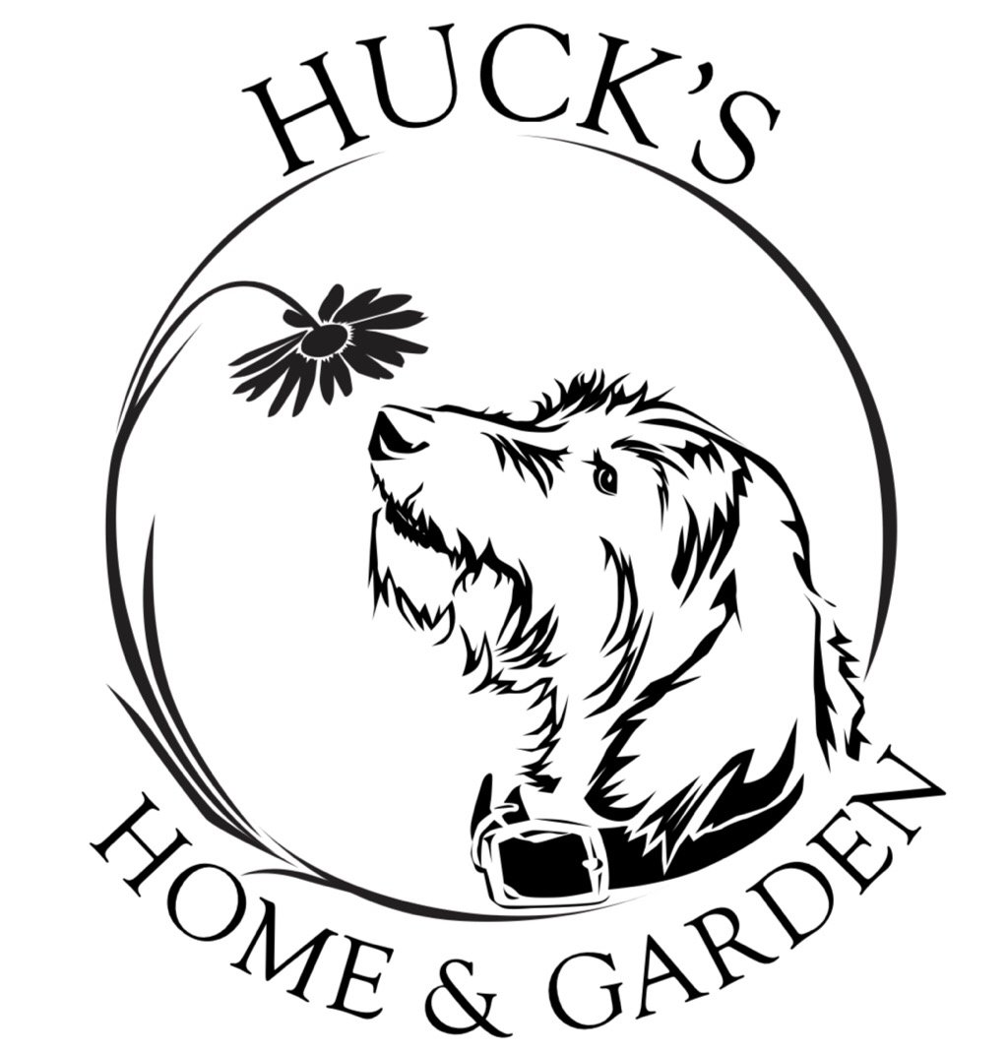 Huck’s Home & Garden LLC.
Where happiness blooms with ever visit
Wholesale Cash Application & Agreement

PRINT NEATLY TODAY’S DATE______________

Business
Name
Street address
If PO Box: Need Street address also
City State Zip

Phone | Cell | Fax
Email |  | How many years in business?  YRS MO
Is your company Tax Exempt Y or N |  | Certificate must be provided if  tax exempt

Federal ID# or SS#
REQUIREMENT: YOU MUST PROVIDE PROOF OF QUALIFYING BUSINESS .
This Application is for a wholesale cash account, which entitles you to wholesale pricing. All information requested must be provided or the application will be denied. Proof of Business in business catagory is required: Huck’s Home & Garden LLC. reserves the right to close an account or refuse purchasing under certain circumstances; Returned Checks and non-payment will be grounds for the closing of an account.
- I’ve attached a business card
- I’ve attached a voided business check
- My website address www._______________________________________________

Owner(s) or officer(s) information HOME ADDRESS :
Name Title Street City State Zip

1.
2.
3.

Huck’s Home & Garden LLC. Wholesale Cash Application (turn to back side to complete form)

Terms and Conditions This Application is for a wholesale cash account

- All purchases are CASH and for business use only. We accept checks drawn on the wholesalers account ONLY! We do not accept third party checks. Texas sales Tax 8.25% will be added to all orders unless we are provided with a valid Texas Sales Tax Exemption Certificate in advance of the purchase(s).
- Should payment by check not be honored by the institution upon which it was drawn, the lesser of $30.00 or the maximum amount allowed by law may be charged to the customer. We reserve the right to charge 1 ½% interest on any outstanding balance not paid within 30 days.
- Upon default, Huck’s Home & Garden LLC. may place customer’s obligation with an attorney for collection, at which point, the parties agree that an additional (25%) of the outstanding balance due will be paid as attorney’s fees.
- This application has been executed and delivered to Huck’s Home & Garden LLC. by the customer, in Lumberton Texas. This Application and the obligations of the customer hereunder shall be governed by, interpreted and determined in accordance with the laws of the Commonwealth of Texas, without reference to the principles of conflicts of laws.
- The customer hereby absolutely and irrevocably consents to the jurisdiction of the courts of the Commonwealth of Texas and of any federal court located in the Commonwealth of Texas in connection with any actions or proceedings brought against the customer by Huck’s Home & Garden LLC. or any other holder hereof arising out of or relating to this cash account application.
- Authority Persons Obligated; Signer Obligated: the signer agrees that he/she has the authority and is signing this agreement (1) in his/her individual capacity, (2) as a representative of the Customer, and (3) as a representative of the entity identified in the application or for whose benefit the goods are being purchased (if the entity identified in the application is not the same as the Customer or the signer). By his/her execution of this agreement the signer personally and individually undertakes and assumes, jointly and severally with the Customer, the full performance of this agreement, including payment of amounts due hereunder together including but not limited to those set forth in ¶ 3 above.

I, hereby, represent that I am authorized to execute the terms and conditions of this application and I authorize Huck’s Home & Garden LLC. to verify any and all information contained in this application. I understand and agree to the terms of this agreement.

Authorized Signature of Applicant__________________________________________________

Print Name Clearly_______________________________________________________________

Date of Birth_____________________________________________Today’s Date ___________

Choose only one category that best describes your business:
Landscape Construction |  | Landscape Maintenance |  | Garden Center/Farm
Architect/ Designer |  | Property Management Co |  | General Contractor, (mason, lighting, pool co. irrigation , excavation)
Municipality |  | Golf Course |  | Florist

Persons authorized to make purchases: Print clearly
- 4.

2. 5.

3 3. 6.
.
EMAIL TO: MITCH@HUCKSHG.COM OR CARLY@HUCKSHG.COM CALL:409-227-4358

